**Pokémon Match**

GitHub Repository: <https://github.com/Danbob81/Pokemon_Match>

Deployed website: <https://danbob81.github.io/Pokemon_Match/>

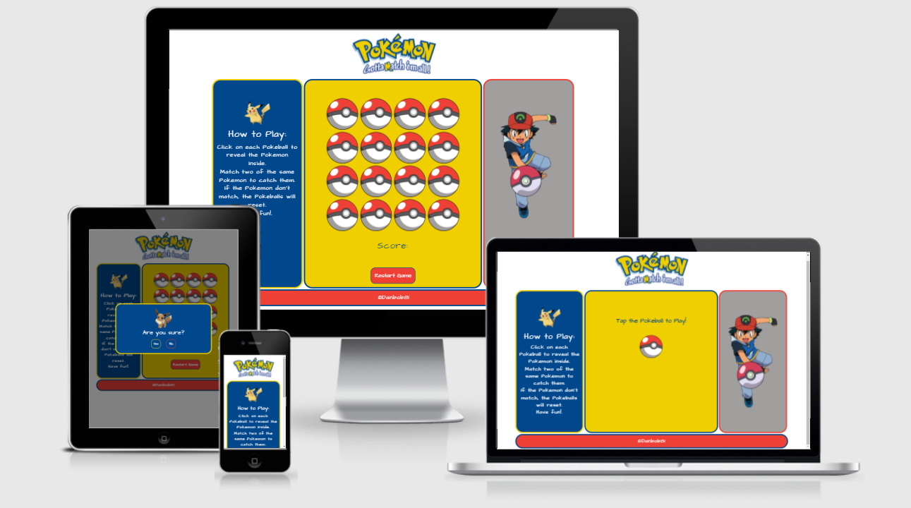

# Scenario

I wanted to create a fun little game, based on the popular Pokémon franchise, that would test the players memory skills.

# Task

To build a web app that is aesthetically appealing, especially to fans of Pokémon, with the functionality being:

* A simple game to test the players memory by matching up pairs of hidden images
* Images are revealed when the card is clicked on but hidden again if no match is found
* When a match is made, the revealed images remain on show
* Sound effects play throughout the different stages of the game
* A score counter to show progress
* A ‘congratulations’ message to pop up on completion of the game when all matches have been found
* Buttons to restart or replay the game
* A brief explanation of the rules of the game

# Action

I created the website using VSCode and GitHub. Bootstrap was used for the layout and the modals. I used Google Fonts for all text.

Steps taken to create the website:

* Create wireframes (using Balsamiq) to get an idea of how I want the app to look
* Create index.html, style.css and script.js files
* Create assets folder with images, css and js folders within the assets folder
  + Place style.css and script.js files within their respective folders
  + Place image files (downloaded from various web sources) in images folder ready for use within the application
* Start creating the layout (using Bootstrap) in index.html with the Pokémon logo as a header and three sections and a footer for:
  + Rules
  + Game play
  + Image
* Add some styling in style.css with contrasting background colours and borders to the sections, using the Pokémon colour scheme
* Using media queries in style.css, create layout changes to be responsive across different screen sizes i.e. desktop, tablet and mobile views
* Create JavaScript code, in script.js, to enable game functionality
  + Here I used a YouTube tutorial to help with the JS code – link here:
    - Learn JavaScript by Building 7 Games -Full Course <https://bit.ly/3D45TUl> from freeCodeCamp <https://bit.ly/3bZtVE8>
* Create sounds folder within assets and add sound files downloaded from web sources
* Create JS function to play audio files and to be called in various places within main JS functions
* Create button to give user option to restart the game
* Create modal to request confirmation of restart with yes/no choice
* Create modal to give ‘congratulations’ message on completion of the game, also giving the option to replay

Throughout the process I made adjustments within the JavaScript code to better suit the application needs. I also made style, margin and layout changes using Google Chrome Developer tools to test the applications functionality and responsiveness across different screen sizes.

A more precise record of the process can be seen via the commit messages in my Pokémon Match GitHub repository via the link at the top of this report.

# Result/Test

For testing the different viewport sizes for desktop and laptop views, tablet views and mobile views, I used the Google Chrome Developer Tool. I used this throughout the development process as well as for testing the website once it was deployed to GitHub Pages.

I also tested the site using Chrome, Edge and Firefox as well as on mobile (using Chrome for Android).

Black box testing was carried out on final deployed website as shown below:

|  |  |  |  |  |
| --- | --- | --- | --- | --- |
| **Test No.** | **Test Feature** | **Expected Result** | **Actual Result (Pass/Fail)** | **Comments** |
| 1 | Open/Launch website | Website opens and displays all elements correctly | Pass | Tested in Chrome, Edge & Firefox |
| 2 | Logo/Company name | Logo/company name available in stipulated colour | Pass |  |
| 3 | Font colour/sizes/styles | Font colour/sizes/styles as expected | Pass |  |
| 4 | Finished website layout | Finished website layout matches planned layout | Pass |  |
| 5 | Images | Images display as expected | Pass |  |
| 6 | Intra-link within a webpage (using text/image as the link medium) | Hyperlinks user to a different section of the same webpage or pop-up/modal within the same page | Pass | Modal opens for restart confirmation. Also another modal opens at completion of game |
| 7 | Inter-link across webpages in the same website (using text/image as the link medium) | Hyperlinks user to a different webpage within the same website | N/A | Not applicable in this case |
| 8 | External-link across webpage onto a different website (using text/image as the link medium) | Hyperlinks user to a webpage in a different website | Pass | Link in footer opens in new tab |
| 9 | Game layout | Displays correctly and uniformly | Pass | Layout even across different screen sizes |
| 10 | Game playability | Images are shown/hidden as they should when clicked | Pass |  |
| 11 | Sound effects | Sounds are played when expected | Pass |  |
| 12 | SPaG / Proof-reading | Spelling, Punctuation and Grammar all correct | Pass |  |

# Reflections/Evaluation

I have met the requirements of the client by creating a web application which incorporates a memory match game which is based upon the Pokémon franchise. The game offers feedback in the form of sound effects during gameplay and a congratulations message on game completion.

This can be seen from the test results above.

If I were to expand or recreate the web app I would do so with the inclusion of a timer which gives the user a time limit in which to complete the game. I might also include a scoreboard feature where players can check their score/time against other players.